Chairperson Message

A Message from Chairman’s Desk

“Together one mind, one heart, one soul, one small step at a time, we can make some difference towards a better world, a brighter tomorrow”

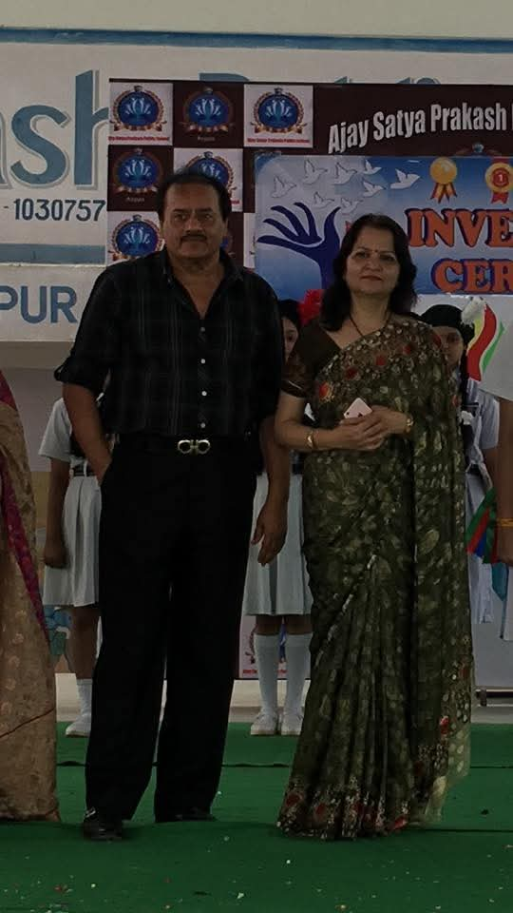
Mr. & Mrs. GROVER

Chairperson

We believe that education is the most important aspect of growth and an educated population solves many problems. With this objective we nurture the children as learners, inculcate values, ensure discipline, good manners and equip them with the necessary skills that will help them to evolve as confident and smart global citizens who will be empowered to think out of the box, act with conviction and lead effectively.
Thus our child – centric approach is aimed at the holistic development of students. In addition to the academics, we also emphasize on physical, mental and personality development of the students
Further our school curriculum allows our teachers to adopt innovative methods to stimulate Interest and attention among the students. Our achers are trained not to teach but are also expected to inspire confidence and trust in their students and become role models.
Lastly We extend my heartfelt gratitude to the school’s Principal, Staff members, students, Parents and well-wishers for their unprecedented support and cooperation.
Thanks & Regards
Mr. Ajay Grover & Mrs. Nisha Grover

